**Personal Assistance for Seniors Who Are Self-Reliant**

|  |  |
| --- | --- |
| **PROJECT NAME** | Personal Assistance for Seniors Who Are Self-Reliant |
| **TEAM ID** | PNT2022TMID26050 |
| **TEAM MEMBERS** | POOJA D K S  APARNA D  NARMADHA R  AKSHAYAA V |
| **BRANCH** | ELECTRONICS AND COMMUNICATION ENGINEERING |

**Abstract:**

*It is of little surprise that falling is often accepted as a natural part of the aging process. In*

*fact, it is the impact rather than the occurrence of falls in the elderly, which is of most concern. Aging people are typically frailer, more unsteady, and have slower reactions, thus are more likely to fall and be injured than younger individuals. Typically, research and industry presented various practical solutions for assisting the elderly and their caregivers against falls via detecting falls and triggering notification alarms calling for help as soon as falls occur in order to diminish fall consequences. Furthermore, fall likelihood prediction systems have been emerged lately based on the manipulation of the medical and behavioral history of elderly patients in order to predict the possibility of falls occurrence. Accordingly, response from caregivers may be triggered prior to most fall occurrences and accordingly prevent falls from taking place. This paper presents an extensive review for the state-of-the art trends and technologies of fall detection and prevention systems assisting the elderly people and their caregivers. Furthermore, this paper discusses the main challenges, facing elderly fall prevention, along with suggestions for future research directions.*

**Introduction:**

In around 35 years and by 2050, it’s estimated that more than one in each group of five people will be aged 65 or over. In this age group, falling is one of the most serious life-threatening

events that can occur, as approximately one-third to one-half of the population aged 65 and over

(mostly aging care centers residents) experience falls on a yearly basis and half of these elderly

do fall repeatedly [1]. So, the automatic detection of falls would help reducing the time of arrival

of medical caregiver, and accordingly reducing the mortality rate [2]. Falls are the leading cause

of injury in elderly people and the leading cause of accidental death in those 75 years of age and

older [3]. Also, more than 90% of hip fractures occur as a result of falls in persons aged 70 years

and over [4]. Falls not only cause physical injury such as many disabling fractures [5]; they also

have dramatic psychological, medical and social consequences. The emerging picture is that falls

are not a rare occurrence among older persons.

**Literature Survey:**

•      **A Self-Reliant Umbrella**

•       **Lin Chen**

The Chinese old-old (80+) population has steadily increased in recent years; however, limited studies have examined how this group ages. The purpose of this study is to explore how the old-old in urban China defines successful aging. Guided by grounded theory, we conducted semi-structured, in-depth interviews with community-dwelling old-old participants (N = 97). Participants identified self-reliance as the goal of successful aging, which was supported by four proactive behaviors: physical activity, financial security, community connectedness, and willing acceptance of reality. In our model, we conceptualized these four proactive behaviors to constitute the ribs of an umbrella, supporting a canopy to protect the pole of self-reliant successful aging. This study offers a new understanding of the dynamic and nuanced ways that the old-old in urban China age successfully and of their valiant efforts to maintain self-reliance.

**ADVANTAGES AND APPLICATIONS:**

•        Staying Connected in the Community

•        Maintaining Financial Security

•        Participating in Physical Activity

•        Aiming for Self-Reliance

* **An IoT Solution for Independent Elderly**
* **[Elena Borelli](https://www.researchgate.net/profile/Elena-Borelli)**

In this work, a flexible and extensive digital platform for Smart Homes is presented, exploiting the most advanced technologies of the Internet of Things, such as Radio Frequency Identification, wearable electronics, Wireless Sensor Networks, and Artificial Intelligence. Thus, the main novelty of the paper is the system-level description of the platform flexibility allowing the interoperability of different smart devices. This research was developed within the framework of the operative project HABITAT (Home Assistance Based on the Internet of Things for the Autonomy of Everybody), aiming at developing smart devices to support elderly people both in their own houses and in retirement homes, and embedding them in everyday life objects, thus reducing the expenses for healthcare due to the lower need for personal assistance, and providing a better life quality to the elderly users.

* **APPLICATIONS AND ADVANTAGES:**
* Easy to install.
* Pleasentness to wear and tactile feel.
* Pleasentness with different colors and texture
* Smart Homes for Elderly Healthcare
* [Sumit Majumder](https://pubmed.ncbi.nlm.nih.gov/?term=Majumder%20S%5BAuthor%5D), [Emad Aghayi](https://pubmed.ncbi.nlm.nih.gov/?term=Aghayi%20E%5BAuthor%5D)

Advancements in medical science and technology, medicine and public health coupled with increased consciousness about nutrition and environmental and personal hygiene have paved the way for the dramatic increase in life expectancy globally in the past several decades. However, increased life expectancy has given rise to an increasing aging population, thus jeopardizing the socio-economic structure of many countries in terms of costs associated with elderly healthcare and wellbeing. In order to cope with the growing need for elderly healthcare services, it is essential to develop affordable, unobtrusive and easy-to-use healthcare solutions. Smart homes, which incorporate environmental and wearable medical sensors, actuators, and modern communication and information technologies, can enable continuous and remote monitoring of elderly health and wellbeing at a low cost. Smart homes may allow the elderly to stay in their comfortable home environments instead of expensive and limited healthcare facilities. Healthcare personnel can also keep track of the overall health condition of the elderly in real-time and provide feedback and support from distant facilities. In this paper, we have presented a comprehensive review on the state-of-the-art research and development in smart home based remote healthcare technologies.

**APPLICATIONS AND ADVANTAGES:**

* Healthcare services
* Transportation
* Security and surveillance

**Objective:**

There are several reasons why elderly fall. Some reasons; such as age, gender, being unconscious, or suffering from chronic neurological or mental problems, cannot be controlled. Whereas other causes; such as medications side effects, insufficient vision, poor hearing, or muscle weakness can be controlled or modified. On the other hand, considering the fact that the leading causes of injury and mortality for elderly people are no longer infectious in nature, personal factors appear to also contribute to increase risk of falling. Intrinsic or personal factors, which relate to age-associated physiological and neurological functions changes, medications (such as: antidepressants or sedatives), as well as diseases (such as: hypertension, osteoarthritis, diabetes and sensory impairment, Alzheimer’s disease or other forms of dementia, etc.), represent factors related to co-morbid conditions and reflect the rise and predominance of chronic diseases and accordingly the rise of elderly falls rate due to these diseases

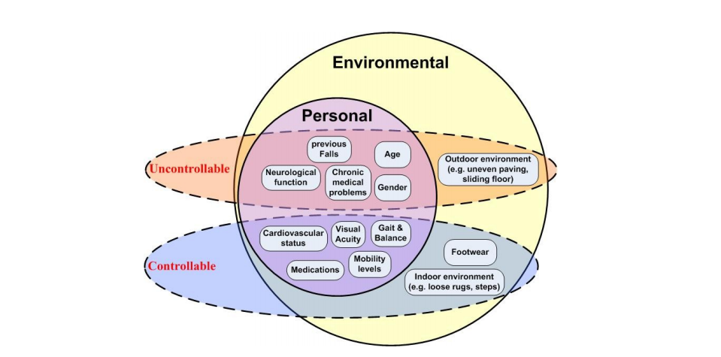

**Proposed Method :-**

**a. Wearable and hand-held solutions**

Many proposed approaches, based on the technology of accelerometers and gyroscopes, have

been proposed for tackling the fall detection and prevention issue. The accelerometer is a device

that can detect the magnitude and direction of acceleration along a certain axis

Using tri-axial accelerometers with applying thresholds, is one of the most common and simple

methodology for objectively monitoring a range of human movements as well as fall detection

So, any motion that exceeds some threshold value of acceleration will be considered a fall. As

when a person falls, their orientation often changes from vertically standing to horizontally lying

on the floor. Hence, analyzing post-fall orientation, in addition to acceleration threshold, is an

important approach to be considered. Also, taking the dot product or cross product of the axial

accelerations to obtain the cross product magnitude and angle change is considered as more

advanced fall detection approach [45]. Researchers generally agree that optimal fall sensor

placement on the body is at the waist [44, 46]. The gyroscope, which is a device measures

orientation, consists of a spinning wheel whose axle is free to take any orientation [43]. Like an

accelerometer gyroscope can measure the orientation along one or multiple axes. Using

gyroscopes with a similarly-placed gyroscope that measures pitch and roll angular velocities with

applying a threshold algorithm to angular change, velocity, and acceleration, can be successful in

fall and tilt detection

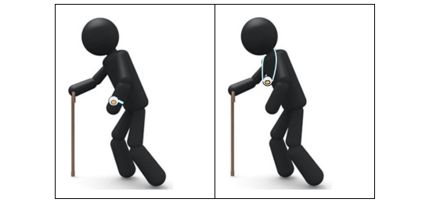

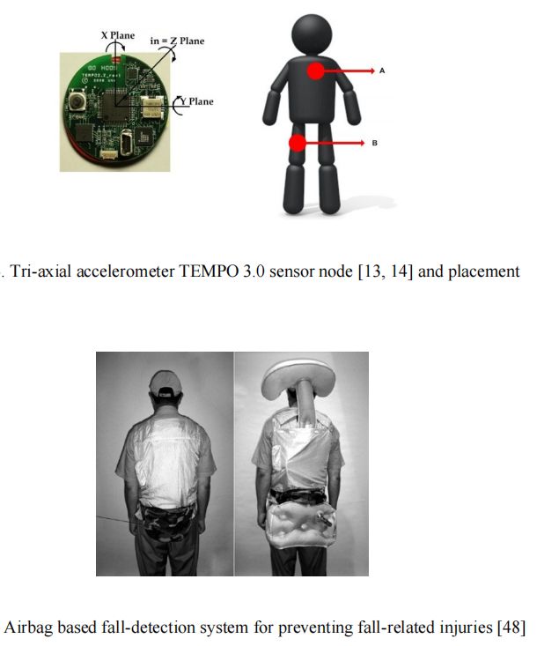

**Circuit Diagram :-**

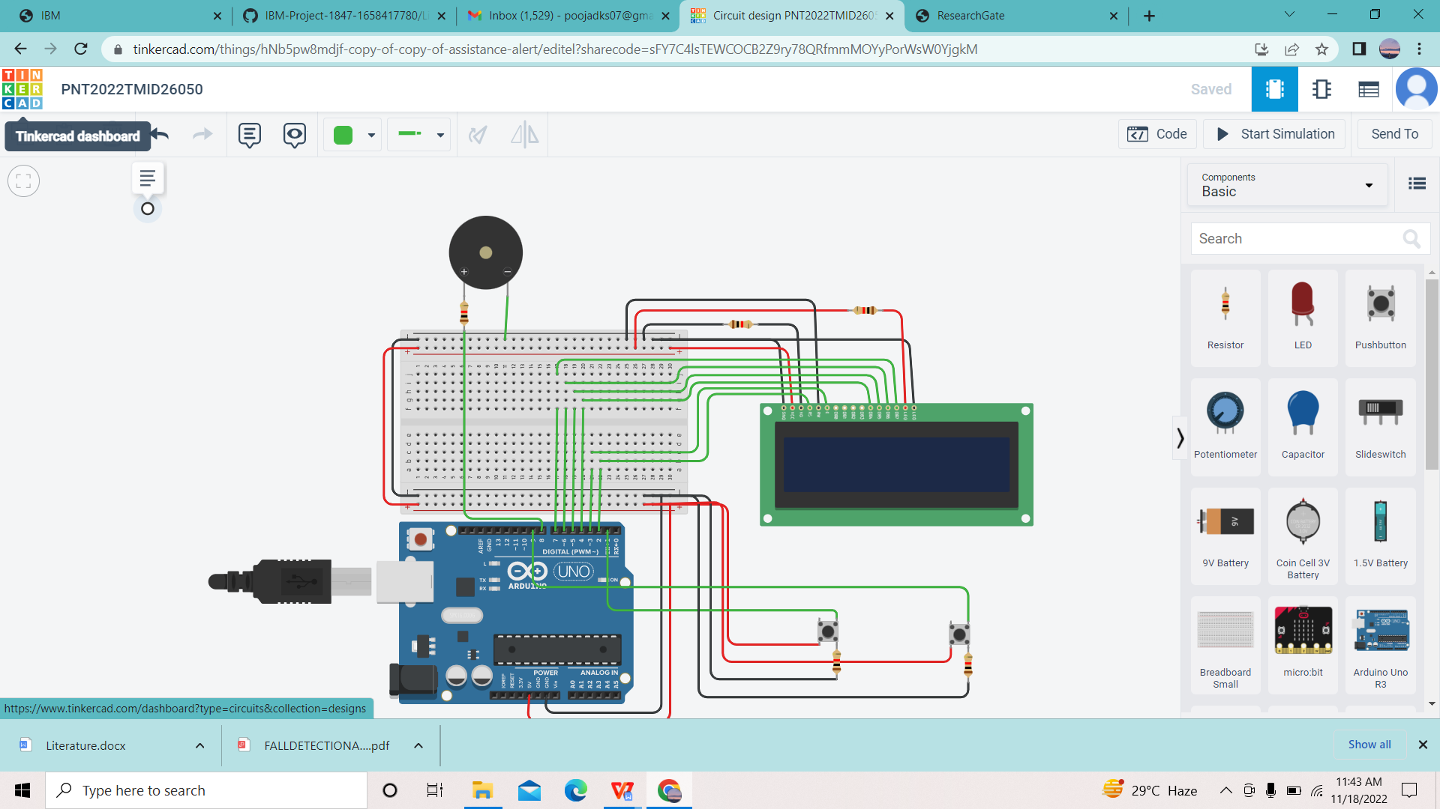

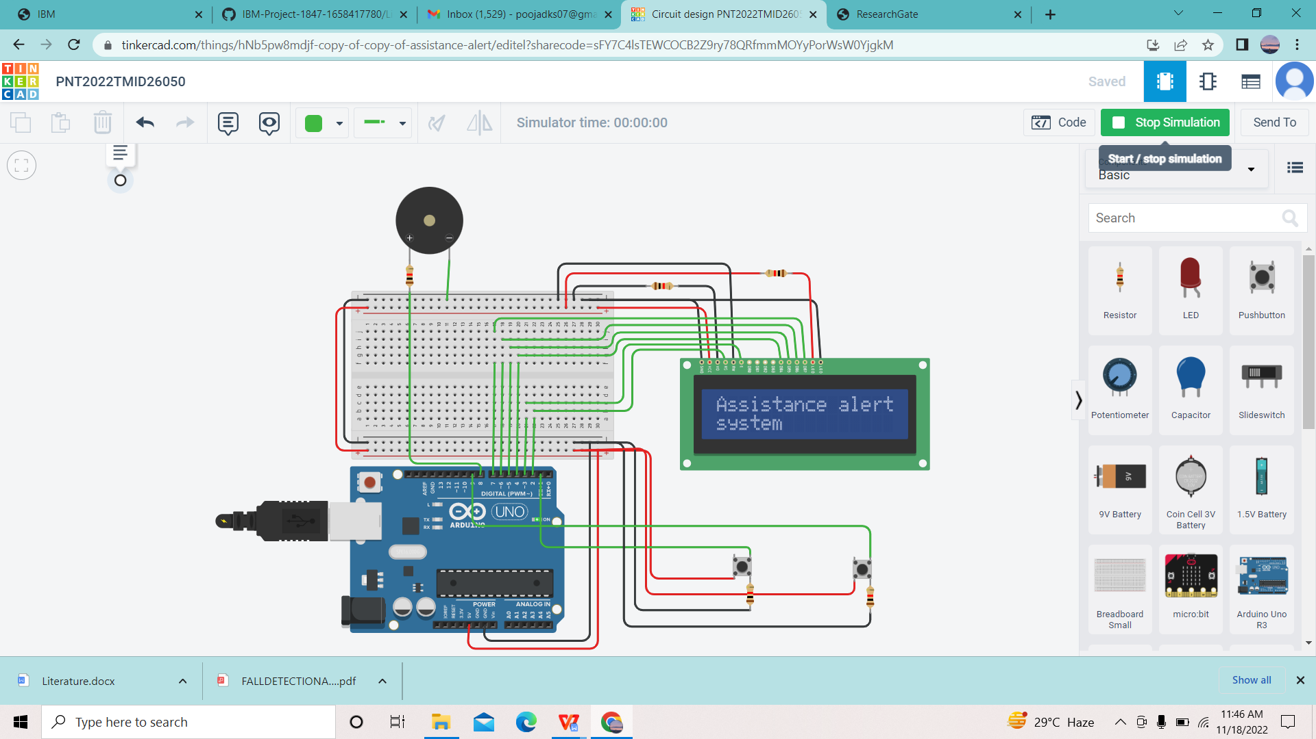

**Solution Statement:-**

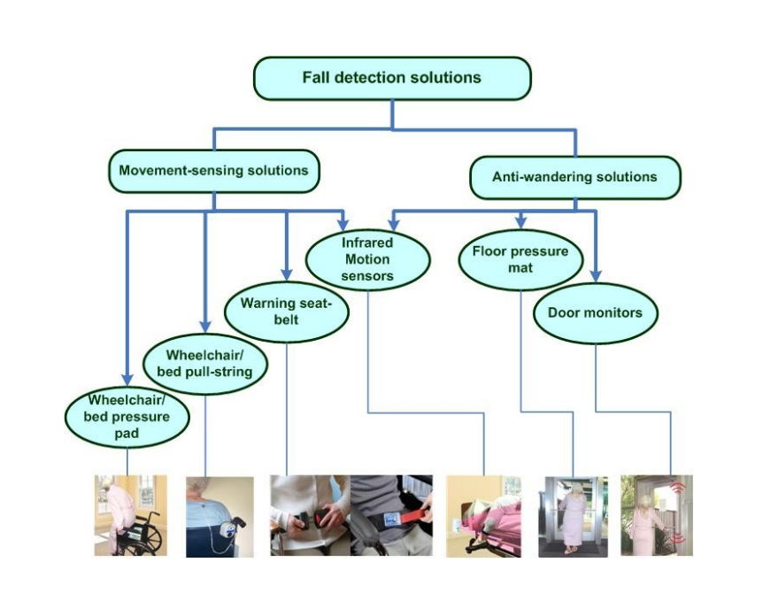

Generally, all monitoring algorithms and approaches for fall detection and prevention relying on

only one data provider (movement-sensor, camera, accelerometer, etc.) have their own limitations and do not ensure 100% reliability . In fact, preventing falls and injuries is difficult because they are complex events caused by a combination of intrinsic impairments and disabilities with or without accompanying environmental conditions. Algorithms for fall detection for several environments and the subject’s physical condition were rather troublesome; however, a combination of movement sensors and signal-processing technologies can provide more accurate and precise fall detection and prevention approaches. Data fusion based on multi-sensing technology offers many challenges for providing more accurate approaches for fall detection and prevention. Multi-sensor data fusion is the area focusing on creating multi-modal systems, which receive data from several providers and perform correlation or fusion upon it in order to increase the accuracy and reliability of the proposed systems.

**Output:-**

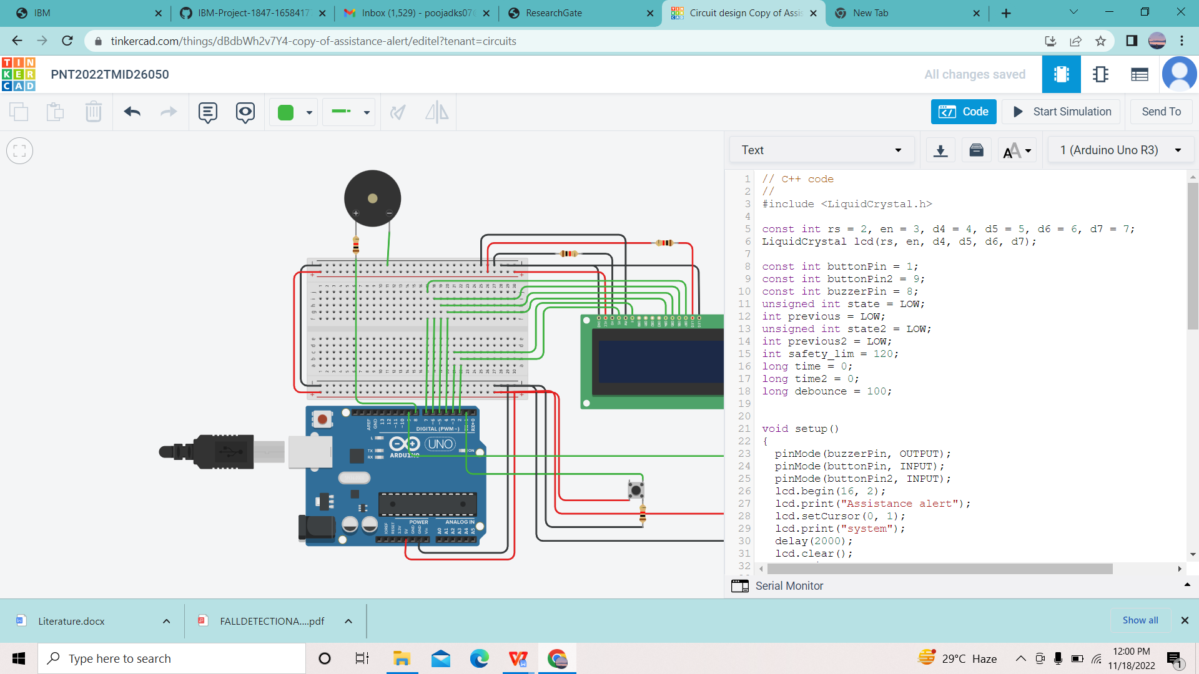

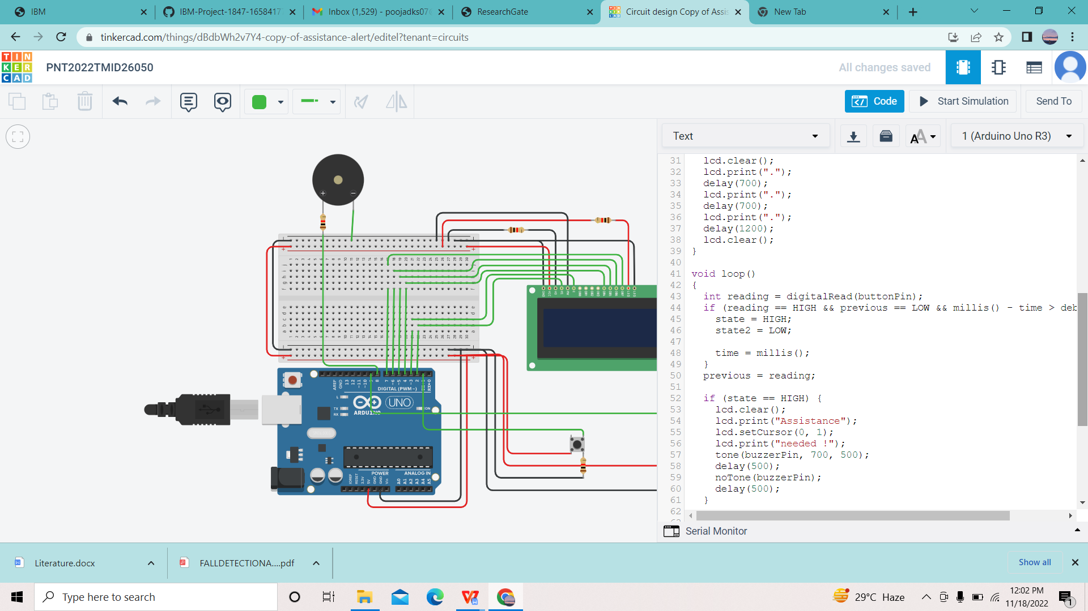

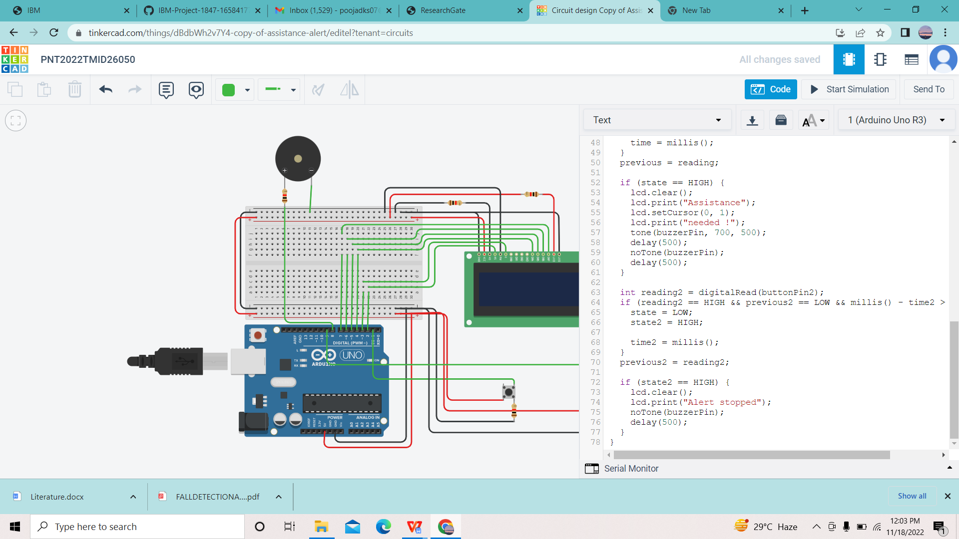

**Conclusion:-**

Finally, elderly people in long-term care centers or aging persons with cognitive impairment,

who have not widely considered in this survey, are as well at high risk of falling and more

specialized technology solutions must be developed specifically for these populations.